**System Test Plan**

Feeler

Index

2 Introduction 3

2.1 Document goal 3

2.2 References 3

3 Testing 4

3.1 Baseline 4

3.2 Product analysis 4

3.3 Strategy 5

3.4 Logical testcases 5

3.5 Physical testcases 6

3.6 Coverage 9

4 Code analysis 10

4.1 Frontend 10

4.2 Backend 10

5 Conclusion 11

# Introduction

## Document goal

This document will define the application’s testing structure on a concrete level.

## References

Where needed, this document will reference any external documents, but all documentation and code can be seen here: [documentation](https://github.com/RDieleman/feeler-documentation), [frontend code](https://github.com/RDieleman/feeler-frontend), [backend code](https://github.com/RDieleman/feeler-backend).

# Testing

## Baseline

To ensure the quality of the tests, here the exact version of software tested will be defined, which components are tested, and which environment they are tested in.

The following components will be tested:

* React frontend progressive web application
* Spring backend application

All unit testing will be done automatically. Whenever a new version is pushed to the main branch of the version management system, Jenkins creates a new build for both components, runs the unit tests, and deploys a new version of the project – if the tests were successful.

For manual tests test version of the project will be used, which is run locally by the tester using WebStorm for the frontend, and IntelliJ for the backend. The database that will be used during testing is an in-memory H2 database.

A test report is generated at the end of every sprint.

The exact version of the application tested will be defined in each iteration of the test reports after testing is complete.

## Product analysis

To determine the how extensive certain components of the application should be tested, a risk class will be determined by defining the chance of failure and the damage if failure does happen.

Both factors will be given a score from 1 to 3, with 3 being the highest chance of failure and the highest amount of damage.

The risk class is determined by multiplying these two scores.

|  |  |
| --- | --- |
| Risk Class | Score |
| C | 1 – 3 |
| B | 4 – 6 |
| A | 7 - 9 |

The targets that are tested are defined in-detail [here](https://github.com/RDieleman/feeler-documentation/blob/main/Analysis%20Document.pdf).

|  |  |  |  |  |
| --- | --- | --- | --- | --- |
| ID | Name | Damage | Chance | Class |
| R01 | GUI Language | 3 | 1 | C |
| R02 | Mobile | 3 | 1 | C |
| R03 | Book Language | 1 | 1 | C |
| R04 | Installable | 2 | 1 | C |
| R05 | Offline use | 2 | 2 | B |
| R06 | Data Security | 3 | 1 | C |
| R07 | Account Security | 3 | 1 | C |
| R08 | Test Coverage | 2 | 1 | C |
| US01 | Explore | 3 | 3 | A |
| US02 | Details | 2 | 2 | B |
| US03 | Bookshelf | 2 | 1 | C |
| US04 | Status | 2 | 1 | C |
| US05 | Account | 3 | 2 | B |
| US06 | Search | 2 | 3 | B |
| US07 | Delete Account | 1 | 2 | C |
| US08 | Encouragement | 1 | 1 | C |
| US09 | Random | 2 | 2 | B |

## Strategy

Here, the test strategy for the previous components will be defined depending on the determined risk class.

The test strategy consists of the necessary types of tests and their severity from 1 to 3. The types of testing consists of unit testing, component testing, and integration testing.

Additionally, it is specified how much is focused on automated testing and manual testing.

|  |  |  |  |  |  |  |
| --- | --- | --- | --- | --- | --- | --- |
| Target | Name | Class | Unit tests | Cmp. tests | Int. tests | Sys. tests |
| R01 | GUI Language | C |  |  |  | ⬤ |
| R02 | Mobile | C |  |  |  | ⬤ |
| R03 | Book Language | C |  |  |  | ⬤ |
| R04 | Installable | C |  |  |  | ⬤ |
| R05 | Offline use | B |  |  |  | ⬤⬤ |
| R06 | Data Security | C | ⬤ |  |  | ⬤ |
| R07 | Account Security | C | ⬤ |  |  | ⬤ |
| R08 | Test Coverage | C |  |  |  | ⬤ |
| US01 | Explore | A | ⬤⬤ | ⬤ | ⬤ | ⬤⬤ |
| US02 | Details | B | ⬤ |  | ⬤ | ⬤ |
| US03 | Bookshelf | C | ⬤ |  |  | ⬤ |
| US04 | Status | C | ⬤ | ⬤ |  | ⬤ |
| US05 | Account | B | ⬤ |  |  | ⬤⬤ |
| US06 | Search | B | ⬤⬤ |  | ⬤ | ⬤⬤ |
| US07 | Delete Account | C | ⬤ |  |  | ⬤ |
| US08 | Encouragement | C | ⬤ |  |  | ⬤ |
| US09 | Random | B | ⬤ |  |  | ⬤ |

## Logical testcases

|  |  |  |
| --- | --- | --- |
| ID | Target | Description |
| TC01 | R01 | Check every page for language use other than English. |
| TC02 | R02 | Check every page with mobile dimensions for GUI bugs. |
| TC03 | R03 | Check received book overview for languages other than English. |
| TC04 | R04 | Install the application. |
| TC05 | R05 | Check offline if books on the want-to-read list are still available. |
| TC06 | R05 | Check offline if books on the reading list are still available. |
| TC07 | R05 | Check offline if books on the read list are still available. |
| TC08 | R06, R07 | Create account to check if password is saved correctly. |
| TC09 | R07 | Try creating an account with a password shorter than 6 characters. |
| TC10 | R08 | Check test coverage of front- and backend. |
| TC11 | US01 | Check if an overview of books is received when exploring with every available emotion. |
| TC12 | US02 | Check for a few books if the detail page is available. |
| TC13 | US03, US02 | Add books to the bookshelf and check if the bookshelf contains them. |
| TC14 | US03 | Check if the overview amount updates. |
| TC15 | US04, US08 | Set an unread book to finished reading and back. |
| TC16 | US03, US04 | Remove a book from the bookshelf |
| TC17 | US05 | Create an account and authenticate the account. |
| TC18 | US06, US01 | Search for books by a title. |
| TC19 | US06, US01 | Search for books by an author’s name. |
| TC20 | US07, US01 | Search for books by a book’s ISBN. |
| TC21 | US07 | Delete a created account. |
| TC22 | US08, US04, US2 | Finish reading a book and close the encouragement screen. |
| TC23 | US09, US01 | Explore an overview of random books. |

## Physical testcases

|  |  |
| --- | --- |
| Outcome | Description |
|  | The test completely passed. |
|  | The test seems to pass, but there is something to remark about the result. |
|  | The test failed. |
|  | The test is not applicable to this version of the application. |

|  |  |  |  |  |
| --- | --- | --- | --- | --- |
| # | Data | | Description | Outcome |
| 1 |  | | Open the application without being authenticated. |  |
| 2 |  | | Open the registration page. |  |
| 3 | **Username** | Test | Register an account with the given data. | Notification that registration failed and stayed on registration page. |
| **Password** | Test |
| 4 | **Username** | Test | Register an account with the given data. | Notification that registration was successful and redirected to authentication page. |
| **Password** | Test12 |
| 5 | **Username** | Test | Authenticate the created account. | Notification that authentication failed and stayed on authentication page. |
| **Password** | Test |
| 6 | **Username** | Test | Authenticate the created account. | Authenticated and redirected to the menu page. |
| **Username** | Test12 |
| 7 |  |  | Redirect to the explore page. |  |
| 8 |  |  | Choose a mood and continue. | Redirected to the overview page where a list of books is displayed. |
| 9 |  |  | Go back to mood page. |  |
| 10 |  |  | Choose a different mood and continue. | Redirected to the overview page where a list of books is displayed. |
| 11 |  |  | Scroll to the bottom of the page and load the next overview of books. | A new list of books is added to the overview. |
| 12 |  |  | Select a random book in the overview. | Redirected to the detail page where the book cover, title, and description is displayed. |
| 13 |  |  | Add the book to the account’s bookshelf. | The overview changes and displays options to remove the book and to start reading. |
| 14 |  |  | Go back to the overview page. |  |
| 15 |  |  | Select a different random book in the overview. | Redirected to the detail page. |
| 16 |  |  | Add the book to the account’s bookshelf. | The overview changes and displays options to remove the book and to start reading. |
| 17 |  |  | Go back to the mood page. |  |
| 18 |  |  | Choose the specific search option. | Redirected to the search page. |
| 19 | **Title** | The Hitchhiker's Guide to the Galaxy | Search for the given title | The specific book is displayed in the overview. |
| 20 |  |  | Select the given book. | Redirected to the detail page. |
| 21 |  |  | Add the book to the account’s bookshelf. | The overview changes and displays options to remove the book and to start reading. |
| 22 |  |  | Go back to the search page. |  |
| 23 | **Author** | Tolkien | Search for the given author. | A list of the author’s books is displayed in the overview. |
| 24 |  |  | Select the given book. | Redirected to the detail page. |
| 25 |  |  | Add the book to the account’s bookshelf. | The overview changes and displays options to remove the book and to start reading. |
| 26 |  |  | Go back to the search page. |  |
| 27 | **ISBN** | 9781474605731 | Search for the given ISBN. | The given book is displayed. |
| **Book** | Flowers for Algernon |
| 28 |  |  | Select the given book. | Redirected to the detail page. |
| 29 |  |  | Add the book to the account’s bookshelf. | The overview changes and displays options to remove the book and to start reading. |
| 30 |  |  | Go back to the home page. |  |
| 31 |  |  | Open the bookshelf page. | Redirected to the bookshelf page. |
| 32 |  |  | Open the want to read page. | Redirected to the overview page where the added books are displayed. |
| 33 |  |  | Select a book in the overview. | Redirected to the detail page. |
| 34 |  |  | Set the book to reading. | The options on the detail page change to remove, finish reading, and stop reading. |
| 35 |  |  | Set the book to finish reading. | A encouragement message is displayed. |
| 36 |  |  | Close the message. | The options on the detail page changed to remove from bookshelf. |
| 37 |  |  | Remove the book from the bookshelf. | The options on the detail page changed to add to bookshelf. |
| 38 |  |  | Go back to the bookshelf page. |  |
| 39 |  |  | Go offline. |  |
| 40 |  |  | Open the want-to-read page. | Redirected to the overview page where the want-to-read books are displayed. |
| 41 |  |  | Select a book in the overview. | Redirected to the detail page. |
| 42 |  |  | Go back online. |  |
| 43 |  |  | Go back to the menu page. |  |
| 44 |  |  | Display the application with mobile dimensions. |  |
| 45 |  |  | Visit every page and check the if the design is properly aligned. | Everything is properly aligned. |
| 46 |  |  | Visit every page and check for any language other than English. | Everything is displayed in English. |
| 47 |  |  | Select the extra options menu. | Redirect to the extra menu page. |
| 48 |  |  | Logout the account. | Redirected back to the authenticate page. |
| 49 | **Username** | Test | Authenticate the account. | The account is authenticated and redirected to the menu page. |
| **Password** | Test12 |
| 50 |  |  | Select the extra options menu. | Redirect to the extra menu page. |
| 51 |  |  | Delete the account. | Redirected to the authentication page. |
| 52 | **Username** | Test | Authenticate the account. | Authentication fails and stays on authentication page. |
| **Password** | Test12 |

## Coverage

|  |  |  |  |  |  |  |  |  |  |  |  |  |  |  |  |  |  |  |
| --- | --- | --- | --- | --- | --- | --- | --- | --- | --- | --- | --- | --- | --- | --- | --- | --- | --- | --- |
|  | | Requirements | | | | | | | | User stories | | | | | | | | |
| **01** | **02** | **03** | **04** | **05** | **06** | **07** | **08** | **01** | **02** | **03** | **04** | **05** | **06** | **07** | **08** | 09 |
| Testcases | **01** | X |  |  |  |  |  |  |  |  |  |  |  |  |  |  |  |  |
| **02** |  | X |  |  |  |  |  |  |  |  |  |  |  |  |  |  |  |
| **03** |  |  | X |  |  |  |  |  |  |  |  |  |  |  |  |  |  |
| **04** |  |  |  | X |  |  |  |  |  |  |  |  |  |  |  |  |  |
| **05** |  |  |  |  | X |  |  |  |  |  |  |  |  |  |  |  |  |
| **06** |  |  |  |  | X |  |  |  |  |  |  |  |  |  |  |  |  |
| **07** |  |  |  |  | X |  |  |  |  |  |  |  |  |  |  |  |  |
| **08** |  |  |  |  |  | X | X |  |  |  |  |  |  |  |  |  |  |
| **09** |  |  |  |  |  |  | X |  |  |  |  |  |  |  |  |  |  |
| **10** |  |  |  |  |  |  |  | X |  |  |  |  |  |  |  |  |  |
| **11** |  |  |  |  |  |  |  |  | X |  |  |  |  |  |  |  |  |
| **12** |  |  |  |  |  |  |  |  |  | X |  |  |  |  |  |  |  |
| **13** |  |  |  |  |  |  |  |  |  | X | X |  |  |  |  |  |  |
| **14** |  |  |  |  |  |  |  |  |  |  | X |  |  |  |  |  |  |
| **15** |  |  |  |  |  |  |  |  |  |  |  | X |  |  |  | X |  |
| **16** |  |  |  |  |  |  |  |  |  |  | X | X |  |  |  |  |  |
| **17** |  |  |  |  |  |  |  |  |  |  |  |  | X |  |  |  |  |
| **18** |  |  |  |  |  |  |  |  | X |  |  |  |  | X |  |  |  |
| **19** |  |  |  |  |  |  |  |  | X |  |  |  |  | X |  |  |  |
| **20** |  |  |  |  |  |  |  |  | X |  |  |  |  |  | X |  |  |
| **21** |  |  |  |  |  |  |  |  |  |  |  |  |  |  | X |  |  |
| **22** |  |  |  |  |  |  |  |  |  | X |  | X |  |  |  | X |  |
|  | **23** |  |  |  |  |  |  |  |  | X |  |  |  |  |  |  |  | X |
| Total | | 1 | 1 | 1 | 1 | 3 | 1 | 2 | 1 | 5 | 3 | 3 | 3 | 1 | 2 | 2 | 2 | 1 |

# Code analysis

Here, the static code analysis is displayed – which includes code coverage for both the back- and frontend.

## Frontend

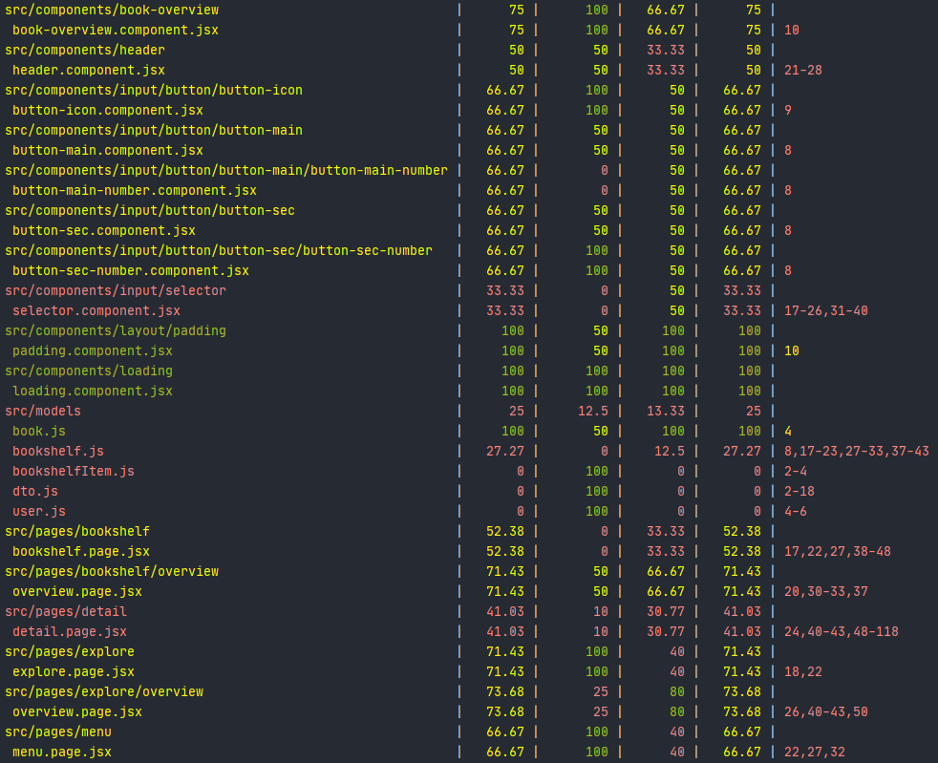

## Backend

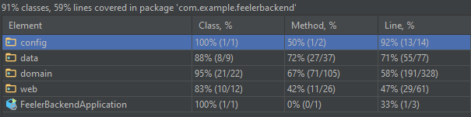

# Conclusion

The functional test cases that were implemented ran well. The exception here is viewing the bookshelf offline. This works in development, but not in production. The reason for this is that the application isn’t server using SSL, which is a requirement for PWAs to work.

The backend test coverage is good, but the frontend needs more testing.